Instructions for installing PVCS Tracker on a workstation.

Prerequisites:
- Must have SQL Server 7.0 ODBC Drivers installed from SQL Server 7.0 CD.
- 25 MBytes free disk space on drive C:
- Window NT Version 4.0 with service pack 3.
- Must be logged into NT with sufficient privileges to install software.
Steps:
- Run \\SVBHQ014\PVCS\Tracker\tknt\setup.exe
- When prompted, copy tracker files locally and click “Next”.
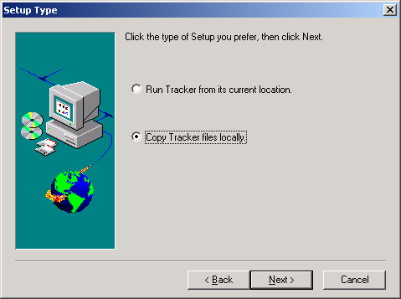
- Verify “PVCS Tracker 3.50 SQL Server” under Databases detected and click “Next” (if database not detected, you have not installed SQL Server 7.0 ODBC drivers).
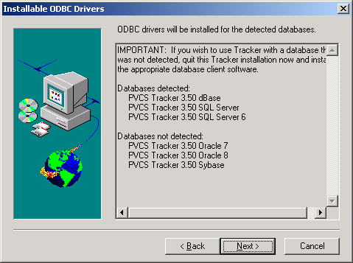
- Select components as indicated below (sub components are for ODBC Drivers), then click “Next”:
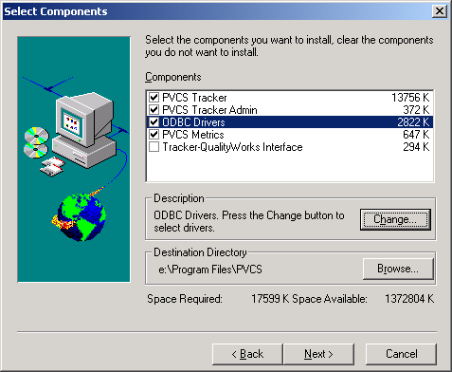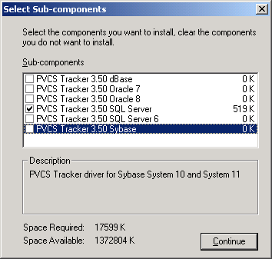
- Selecte “PVCS Tracker” program folder, then click “Next”:
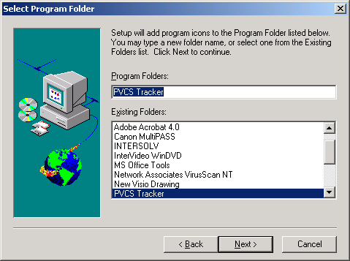
- Verify current settings, then click “Next” (note, in your installation, target directory must read “C:\PVCS”):
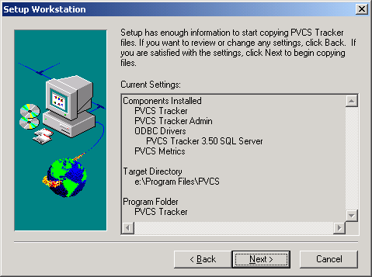
- You may get the following prompt during installation, if so click “No”:
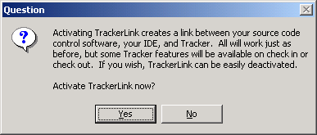
- Installation of PVCS Tracker completes with the following screen. Deselect the option to view the README file and click “Finish”:
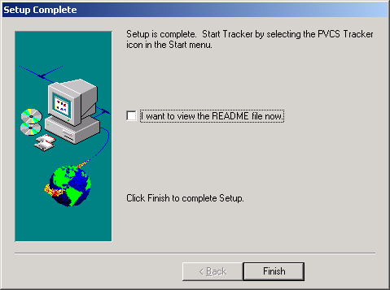
- Now you must configure the ODBC data source installed by Tracker such that it is not login specific, but generic to the machine. To do this, open the ODBC Data Source Administrator tool from the control panel as follows (note the TRK_SS_TK6 User DSN Driver):
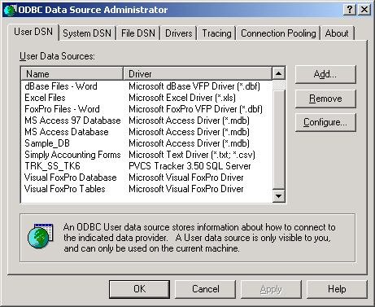
- Delete the TRK_SS_TK6 User DSN (answer Yes to the confirmation prompt), click on the System DSN tab, then click on the “Add” button, select the “PVCS Tracker 3.50 SQL Server” entry and click “Finish”:
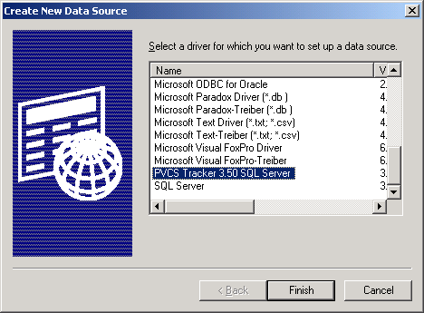
- Complete the first screen as indicated below and click “Next”:
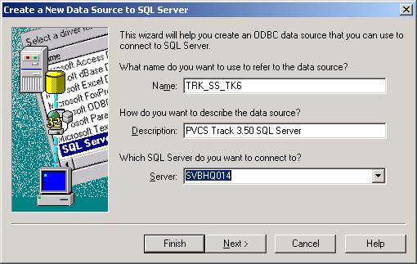
- Complete the second screen as indicated below (Password is “mydear”) and click “Next”:
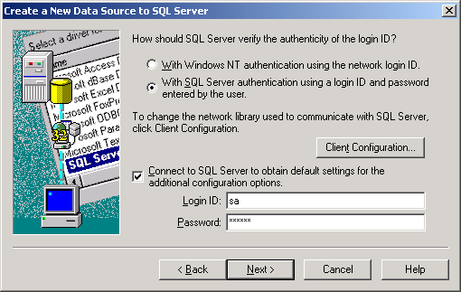
- Click “Next” on the third screen (leave defaults).
- Click “Finish” on the last screen (leave defaults).
- You will get the following configuration confirmation screen:
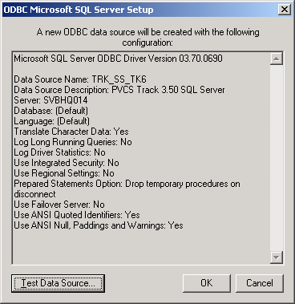
- Click the Test Data Source button and verify that the message “TESTS COMPLETED SUCCESSFULLY!” is displayed in the resulting dialog box.
- Click “OK” on the test dialog box and “OK” on the configuration dialog box.
- Click “OK” to close the ODBC Data Source Administrator tool.
- Create a shortcut on the desktop for all users to “C:\PVCS\Tracker\nt\pvcstkn.exe” (ideally this should be set up for all users).
- Start PVCS tracker by clicking on the desktop shortcut to get the login dialog box. Click the “Advanced” button and complete the screen as follows and complete the connection information as follows:
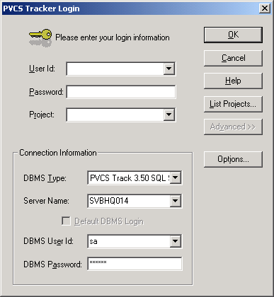
- Click the “Options” button to save the DBMS Passwork and click “OK”:
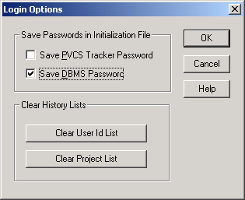
- Once back on the PVCS Tracker Login screen, click the “List Projects” button to display the following dialog box, select the “GIS Issues” project and click OK.
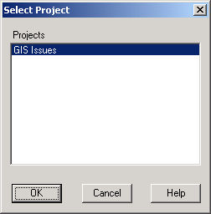
- Now enter a valid PVCS User Name and Password and click “OK” to start Tracker:
